Linear Search

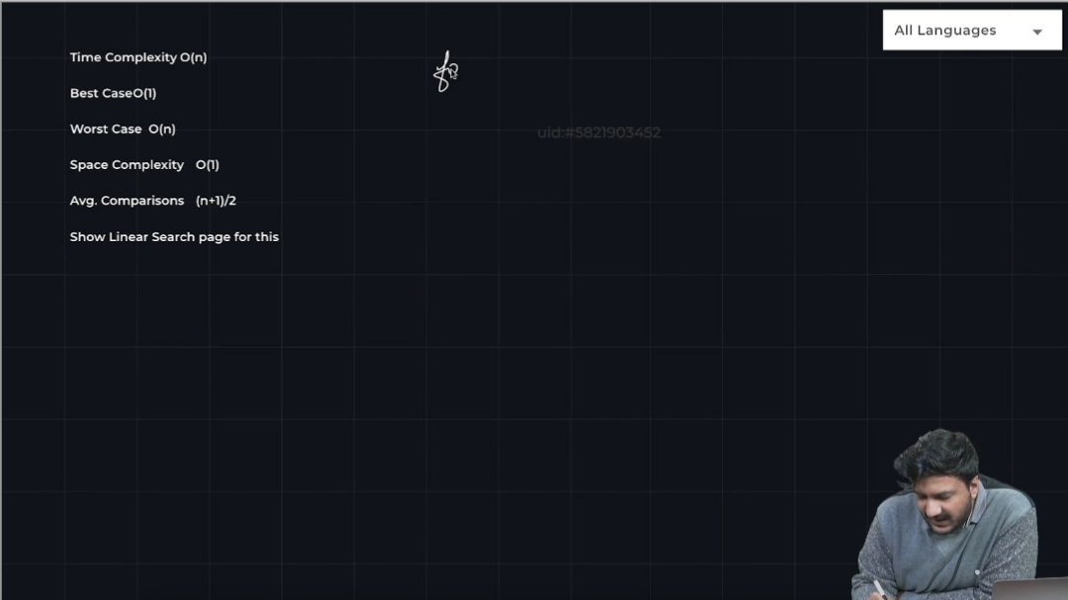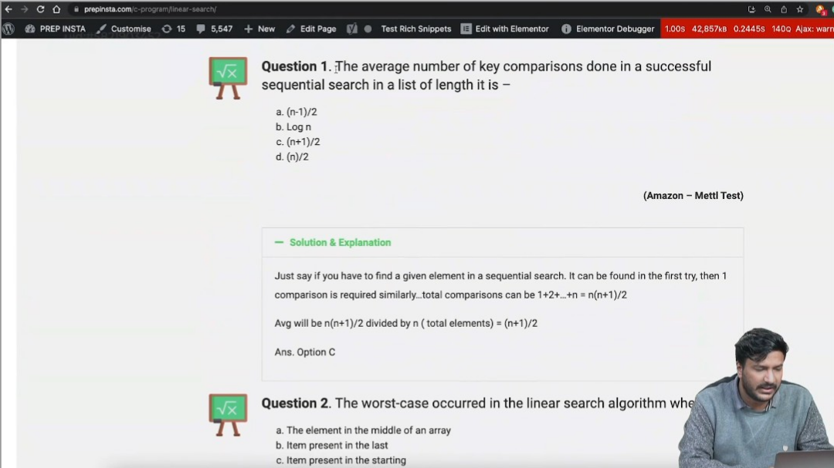

Linear Search is Ok for small sized array

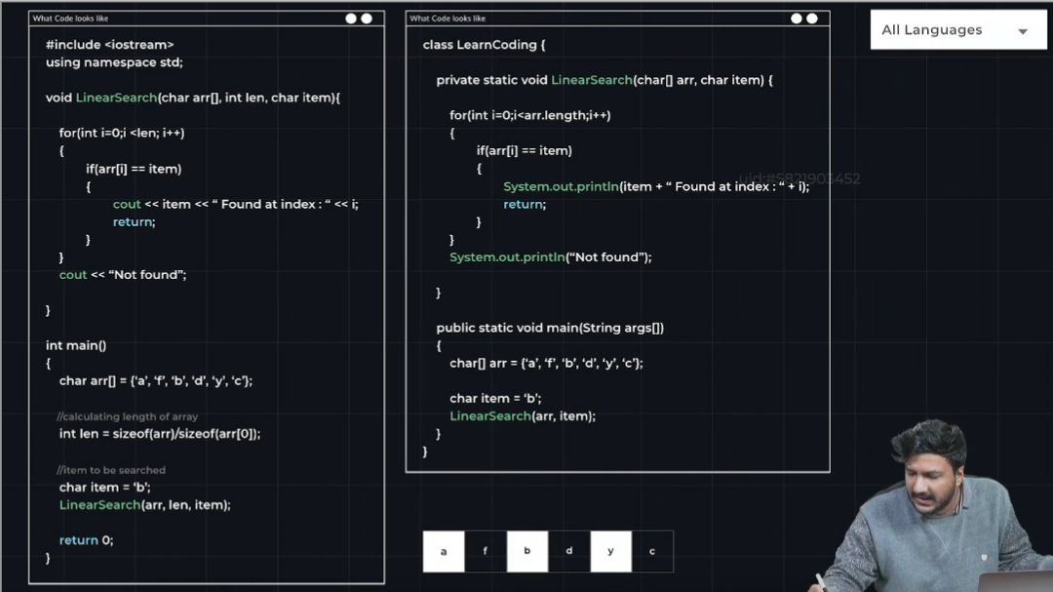

**Binary Search**

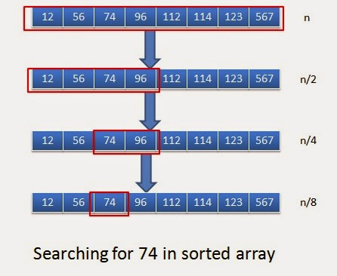

**Time Complexity of**[**Binary Search Algorithm**](https://www.geeksforgeeks.org/binary-search/)**:**

**Best Case Time Complexity of Binary Search Algorithm: O(1)**

*Best case is when the element is at the middle index of the array. It takes only one comparison to find the target element. So the best case complexity is****O(1)****.*

**Average Case Time Complexity of Binary Search Algorithm: O(log N)**

**Worst Case Time Complexity of Binary Search Algorithm: O(log N)**

*The worst case will be when the element is present in the first position. As seen in the average case, the comparison required to reach the first element is****logN****. So the time complexity for the worst case is****O(logN)****.*

**Auxiliary Space Complexity of Binary Search Algorithm**

The**auxiliary space complexity** of the **Binary Search Algorithm** is **O(1)**, which means it requires a constant amount of extra space regardless of the size of the input array. This is because Binary Search is an iterative algorithm that does not require any additional data structures or recursion that grows with the input size. Although, we can also implement Binary Search recursively.